 

**PROJECT ID: 2023CEPID13**

## Mini Project Report

**on**

## "Zombie Land"

**Submitted in Partial Fulfilment of the Requirement**

**For the Degree of**

### Bachelor of Technology

**In**

### Computer Engineering

**By**

Prakhar Mehrotra (2200320150045)

Rohit Kumar (2200320150052)

### Under the Supervision

**of**

**Prof. Anurag Gupta**

**(Sr. Assistant Professor)**

**ABES ENGINEERING COLLEGE, GHAZIABAD**

**AFFILIATED TO**

**Dr. A.P.J. ABDUL KALAM TECHNICAL UNIVERSITY, UTTAR PRADESH, LUCKNOW**

**(ODD SEM, 2023-24)**

## DECLARATION

I hereby declare that the work presented in this report entitled “**Zombieland**”, was carried out by me. I have not submitted the matter embodied in this report for the award of any other degree or diploma of any other university or Institute. We have given due credit to the original authors/sources for all the words, ideas, diagrams, graphics, computer programs, experiments, results, that are not my original contribution. I have used quotation marks to identify verbatim sentences and given credit to the original authors/sources.

We affirm that no portion of my work is plagiarized, and the experiments and results reported in the report are not manipulated. In the event of a complaint of plagiarism and the manipulation of the experiments and results, we shall be fully responsible and answerable.

Name: Rohit Kumar Name: Prakhar Mehrotra

B tech (2nd year) B tech (2nd year)

Roll. No: 2200320150052 Roll. No: 2200320150045

Branch: Computer Engineering Branch: Computer Engineering

ABES Engineering College ABES Engineering College

Ghaziabad Ghaziabad

**(Candidate Signature)**

i

## CERTIFICATE

Certified that **Rohit Kumar (**Roll no. 2200320150052), Prakhar Mehrotra

(Roll no.2200320150045) have carried out the research work presented in this report entitled **“Zombie land”** for the award of **Bachelor of Technology** from Dr. APJ Abdul Kalam Technical University, Lucknow under my/our (print only that is applicable) supervision. The report embodies results of original work, and studies are carried out by the student themselves and the contents of the thesis do not form the basis for the award of any other degree to the candidate or to anybody else from this or any other University/Institution.

Supervisor Signature HOD Signature

**Prof. Anurag Gupta** Prof.(Dr.) Amrita Jyoti

Assistant Professor Incharge of Department (CE) ABES Engineering College, Ghaziabad ABES Engineering College

,Ghaziabad

ii

## ABSTRACT

The Zombie Shooter Game project aims to deliver an interactive and entertaining gaming experience using HTML, CSS, and JavaScript. In this minimalist game, players are tasked with shooting approaching zombies to survive. The game environment consists of a player character, a zombie adversary, and a "Shoot" button to initiate attacks. The development follows a simplistic yet engaging approach. The player is static initially, positioned at the bottom center of the screen, while a zombie starts its approach from the top. Upon clicking the "Shoot" button, the zombie's position is randomized, creating a dynamic challenge for the player. The HTML structure defines the game elements, while the CSS styles enhance the visual appeal and positioning of the player, zombie, and other components. The JavaScript functionality handles the shooting mechanics, currently manifested as the zombie's randomized movement. Future iterations can include enhanced shooting mechanisms, scoring, multiple zombies, and additional features to elevate the gaming experience

# ACKNOWLEDGEMENT

With deep gratitude I express my earnest thanks to my esteemed supervisor **Mr. Anurag Gupta** Assistant Professor, Department of Computer Engineering for his constant involvement, energetic efforts and proficient guidance, which gave me direction and body to work, respond here. Without his counsel and encouragement, it would have been impossible to complete the thesis work in this manner.

I wish to express my gratitude to Prof. (Dr.) Amrita Jyoti(Incharge of Department), and Dr. Devendra Kumar Singh (Director), for their support, guidance and advice throughout this work. I am thankful to all the faculty members of the Computer Engineering Department especially for their intellectual support during my research work. I also want to thank my friends for their valuable support whenever I needed. I would like to thank all those people who have helped me some way or the other in my thesis work.

Lastly, and most importantly, I thank my parents for their moral support and encouragement towards completing my thesis successfully. In the last, I want to thank Almighty God.

Name: Rohit Kumar Name: Prakhar Mehrotra

B tech (2nd year) B tech (2nd year)

Roll. No: 2200320150052 Roll. No: 2200320150045

Branch: Computer Engineering Branch: Computer Engineering

ABES Engineering College ABES Engineering College

Ghaziabad Ghaziabad

|  |  |
| --- | --- |
|  |  |

## TABLE OF CONTENT

Description Page

Declaration i

Certificate ii

Abstract iii

Acknowledgement 5

Table of Content 6

Introduction 7

Purpose of the Project 8

Methodology 9

Result 12

Conclusion 13

References 14

## 

## INTRODUCTION

The Zombie Shooter Game Project embarks on the creation of an interactive and captivating gaming experience, utilizing the fundamental trio of web technologies: HTML, CSS, and JavaScript. In response to the ever-growing interest in browser-based gaming, this project endeavors to offer a simplistic yet engaging game where players face the relentless threat of approaching zombies. The essence of the game lies in its minimalistic design, featuring a player character, a formidable zombie adversary, and a "Shoot" button as the primary means of defense. The player, initially stationed at the bottom center of the screen, must strategically time their shots to fend off the encroaching zombie, which unpredictably repositions upon each attack. The HTML structure establishes the groundwork for the game's elements, while CSS stylings enhance the visual appeal and positioning, creating an immersive environment. The dynamic functionality, powered by JavaScript, orchestrates the shooting mechanics, currently represented by the randomized movement of the zombie.

## Purpose of The Project

The primary purpose of the Zombie Shooter Game project is to provide an immersive and accessible entry point into web-based game development for enthusiasts and beginners. This project serves several key purposes:

**Educational Endeavor**: Acts as a practical learning opportunity for individuals looking to understand the basics of game development using HTML, CSS, and JavaScript. Provides insights into fundamental concepts such as user interface design, interactivity, and dynamic content manipulation.

**Skill Enhancement**: Fosters skill development in front-end web technologies by implementing a simple yet engaging game environment. Encourages participants to refine their HTML, CSS, and JavaScript skills in a creative and interactive context.

Creativity and Customization: Encourages creativity by providing a canvas for participants to customize and expand upon the basic game structure. Allows for the addition of new features, improvements to gameplay, and personalization to suit individual preferences.

**Accessible Game Development:** Demonstrates that game development is not exclusive to specialized platforms and can be undertaken using widely accessible web technologies. Promotes inclusivity by making the development process open and understandable for a diverse audience. **Foundational Experience**: Lays the foundation for future game development by instilling a basic understanding of how game elements interact within a web environment . Serves as a stepping stone for individuals interested in pursuing more complex game projects in the future.

In essence, the Zombie Shooter Game project aims to bridge the gap between theoretical knowledge and practical application, offering a purposeful and engaging journey into the realm of web-based game development. Through hands-on experience, participants can acquire and hone skills that are transferable to broader web development contexts while fostering a sense of creativity and curiosity within the gaming domain.

Research Approach/Methodology

The research approach and methodology for the Zombieland Game project involve a structured process aimed at gathering insights, understanding existing practices, and implementing effective game development strategies. The methodology encompasses the following key steps:

**Literature Review**: Objective: To understand established game development principles and mechanics. Activities: Review existing literature on game development using HTML, CSS, and JavaScript. Explore resources that focus on the creation of browser-based games. Identify successful examples of simple game mechanics and user interfaces.

**Skill Development Research**: Objective: To identify key skills required for front-end web development and game design. Activities: Explore resources and tutorials focused on HTML, CSS, and JavaScript for game development. Identify best practices for creating interactive and visually appealing web content. Investigate methods for incorporating dynamic elements into web-based games.

**Community Engagement**: Objective: To stay updated on industry trends and community discussions. Activities: Participate in game development forums and communities. Seek advice and feedback from experienced developers in web-based gaming. Monitor discussions on emerging technologies and best practices in game development. This research approach ensures a comprehensive understanding of both theoretical and practical aspects of game development using web technologies. It combines insights from existing literature, hands-on analysis of successful games, skill development strategies, community engagement, and iterative prototyping to create a well-informed foundation for the development of the Zombie Shooter Game.

## System Requirements

**Hardware Requirements:**

1- RAM /memory required: 4GB

2- Operating System: Windows

3- Good Internet Connection

4. Processor i5

**Software Requirements:**

1. HTML,CSS,JAVASCRIPT in frontend
2. Vs code

**Hosting platform:** 000webhost

## Result



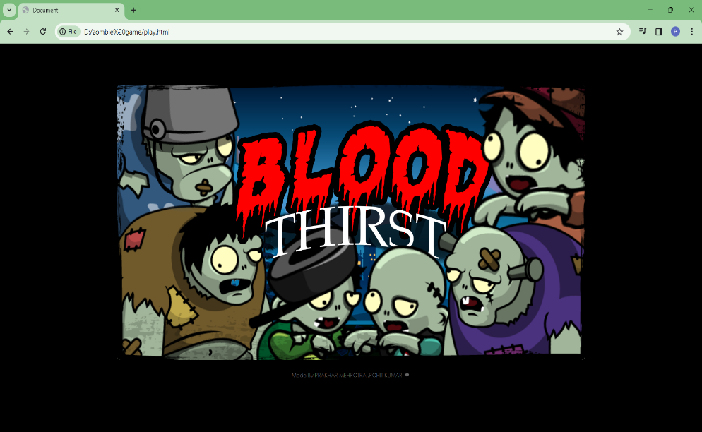

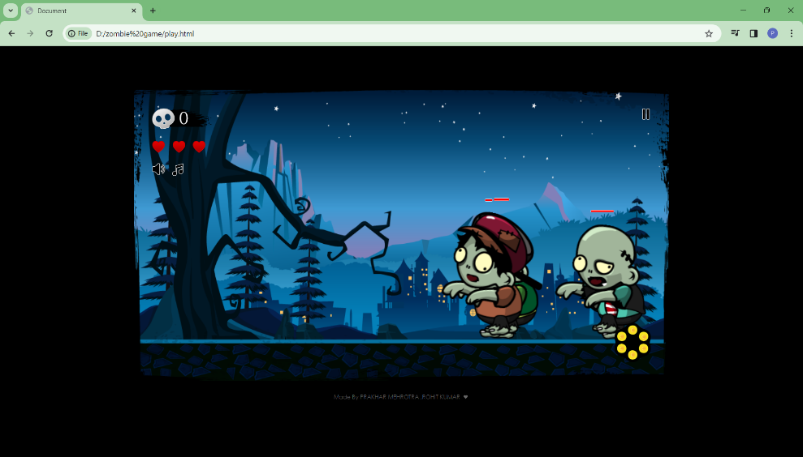

## 

## Conclusion

* Top of Form
* The Zombieland game created using HTML , CSS , and JavaScript successfully combines creativity, interactivity ,and user engagement. The game design and implementation using CSS makes it more user friendly while the dynamic elements powered by JavaScript contribution to the game make’s game more responsive and playability.
* The utilization of JavaScript for game logics, animation and user interactions enhances the overall gaming experience. The game contains the different levels which have different difficulty in them and strategic elements keeps players engaged and motivated to continue playing.
* The project showcases the combination of front-end technology, demonstrating the power of CSS for styling and layout, and JavaScript for creating dynamic and interactive features in game . The responsive design ensures accessibility across different devices, enhancing the game’s reach and user base.
* In conclusion the Zombieland game not only entertains players with its engaging gameplay but also serves as a testament to the capabilities of CSS JavaScript in creating an interactive web-based games. The project stands as a successful integration of design and functionality, providing an enjoyable gaming experience for users.

## References

[1] [**https://www.w3schools.com/html/default.asp**](https://www.w3schools.com/html/default.asp)

[2][**https://getbootstrap.com/**](https://getbootstrap.com/)

[3][**https://panel.000webhost.com/dashboard/zombiekillgame/das hboard**](https://panel.000webhost.com/dashboard/zombiekillgame/das%20%20%20%20hboard)